MSDS 7346

Cloud Computing
Mini Project 2 -- Compute

This is a mini project for MSDS 7346, Cloud Computing. For this assignment, turn in a single pdf file containing all of your answers. The file should be named <yourLastName>MiniProject-Number.pdf. For example, the file name for my mini project 1 would be `RafiqiMiniProject-Number.pdf'.

Collaboration is expected and encouraged; however, each student must hand in their own homework assignment. To the greatest extent possible, answers should not be copied but, instead, should be written in your own words. Copying answers from anywhere is plagiarism, this includes copying text directly from the textbook. Do not copy answers. Always use your own words and your own code. Directly under each question list all persons with whom you collaborated and list all resources used in arriving at your answer. Resources include but are not limited to the textbook used for this course, papers read on the topic, and Google search results. Don't forget to place your name on the first page of the pdf document.

The objective of this lab is to dig deeper into AWS EC2. This is continuation of what we did in the class. Please complete the following steps and take screenshots at each of the steps to submit:

- Create and launch an instance on EC2 with termination protection enabled against accidental termination, naming your instance “My Web Server”

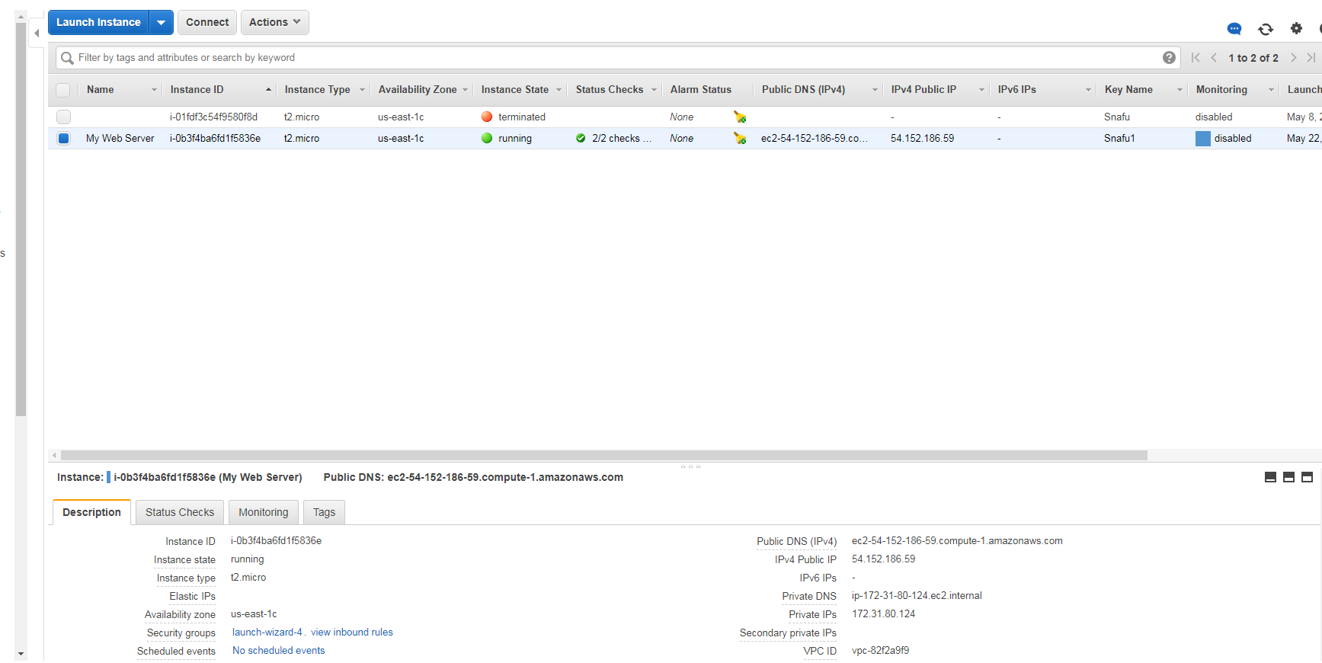

- Insert the following script so that it is executed as EC2 instance is created

#!/bin/bash

yum -y update
yum -y install httpd
chkconfig httpd on
service httpd start
echo "<html><h1>Hello my name is INSERT YOUR NAME</h1> </html>" > /var/www/html/index.html

- Try to access the Web Server (Note: may need to update your security group setting)

- Resize your instance type and EBS volume (change the volume size from 8 GiB to 10 GiB and instance type to t2.small

- Create a custom image
- Launch EC2 instance using the custom image
- Launch Web Server on the custom image

Please submit screenshots for each steps.

